**Low-fidelity sketch**

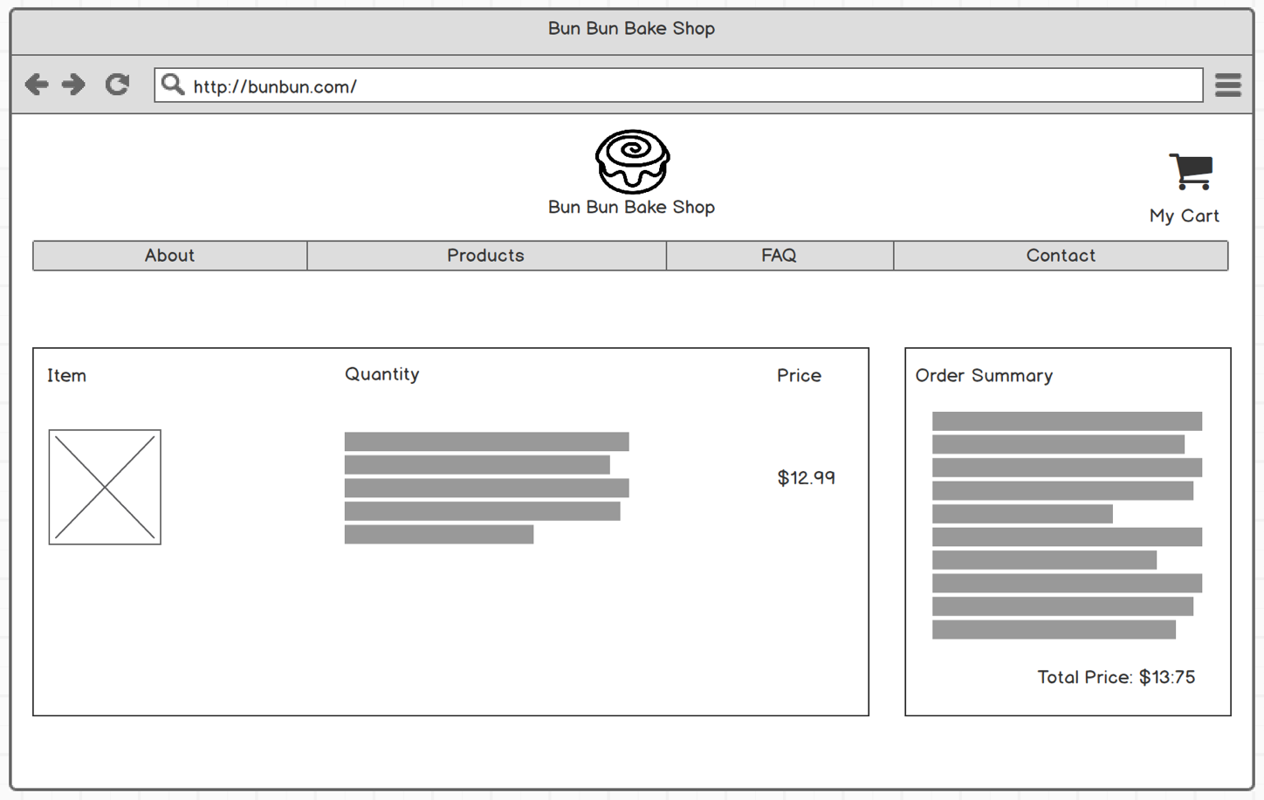

I chose this design because I felt that it addressed all the key elements of a cart in the most logical manner. Users care about seeing a visual image of their item, along with a description of the price and quantity. The order summary section allows the user to get a detailed breakdown of their purchase and understand exactly where their money is going.

**High-fidelity digital mockup**

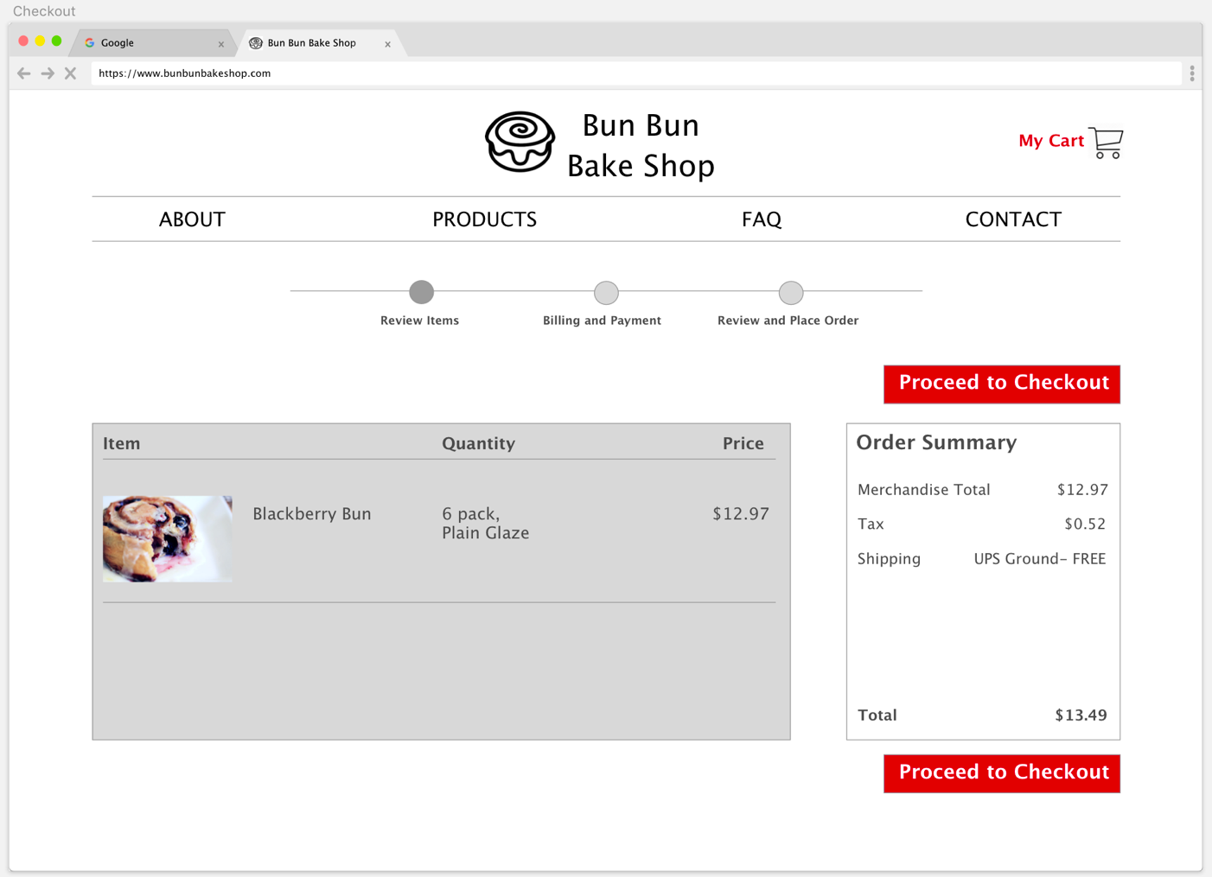

One thing I added to this design was the order summary. As a frequent online shopper, I like to be able to see all the items I’ve chosen, along with a detailed breakdown of my shipping and tax costs. I also added the progress bar at the top, because it’s nice to have an overall idea of where you are in the checkout process. Lastly, I created two ‘proceed to checkout’ buttons. One thing we discussed in class was the fact that you should lead your users to the desired end goal, which for an e-commerce site, would be the checkout page. By creating two bright red buttons, there’s a higher affordance for users to click one of these buttons and complete their purchase.

**Challenges/Bugs**

I encountered quite a few challenges while attempting to complete this assignment.